   

**MONEY MATTERS: A PERSONAL FINANCE**

**MANAGEMENT APP**

**A PROJECT REPORT**

**Submitted by**

**D.Swetha-812022104084**

**S.Srimathi-812022104075**

**A.Shabnam Sajitha-812022104309**

**BACHELOR OF ENGINEERING**

**IN**

**COMPUTER SCIENCE AND ENGINEERING**

**M.A.M. COLLEGE OF ENGINEERING AND TECHNOLOGY**

**ANNA UNIVERSITY : CHENNAI 600 025**

**NOVEMBER 2024**

|  |  |  |
| --- | --- | --- |
| **S.NO** | **CONTENT** | **PAGE NO** |
| **1.** | **Abstract** | **3** |
| **2.** | **Introduction** | **3** |
| **3.** | **Personal Financial Management** | **3** |
| **4.** | **The Importance Of Personal Financial Management** | **4** |
| **5.** | **Steps To Personal Financial Management** | **4** |
| **6.** | **Personal Financial Management Awareness In Brunis** | **7** |
| **7.** | **Source Code** | **9** |
| **8.** | **Output** | **14** |
| **9.** | **Conclusion** | **18** |
| **10.** | **Reference** | **19** |

**MONEY MATTERS: A PERSONAL FINANCE**

**MANAGEMENT APP**

**Abstract**

Financial experts agree that while people have much more money today than they did generations ago, the amount of knowledge on how to manage that money hasn’t kept pace- not at all (Maura Fogarty, 2012). Taking charge of planning and managing our finances and putting it into practice is very important for every individual. This is not only to set up our household budget but also to save, invest as well as plan for our retirement. In this writing, the meaning of financial management, the importance of financial management, how each individual can take steps to manage and plan their finances and the awareness of financial management in Brunei are discussed. The objective of this writing is to create awareness to people the importance of planning and managing their personal finances besides, educating the readers on how to plan and manage every individual’s finances for their better today and future which also indirectly leads to the development of the nation.

**Introduction**

Financial experts agree that while people have much more money today than they did generations ago, the amount of knowledge on how to manage that money hasn’t kept pace- not at all (Maura Fogarty, 2012). Taking charge of planning and managing our finance and putting it into implementation is very important for every individual. We must know how to take control of our money. This is not only to set up our household budget but also to save for the future as well as plan for our retirement and invest for our better future. This is also important as every 2 individual would like to live debt free and not going through stressful life, working until our old age just to survive and educate our children. Every human being should have this awareness and know the importance of their financial planning and management. This writing would be very helpful for those who have less awareness on the importance of personal financial management and also helpful for those who are determined to take charge of their finance and let the money work for them. In this writing, the meaning of financial management, the importance of financial management, how every individual can take steps to manage and plan their finances and the awareness of financial management in Brunei are discussed.

**Personal Financial Management**

According to Towanda Mitchell, financial management is handling our financial situation in a responsible manner to achieve financial independence (UMBC Money Matters Seminar, n.d). It deals with managing money in all areas of life. Financial management includes personal financial management and organization management. Personal financial management helps us to manage the finance of our home which includes budgeting, saving, investing, debt management and other aspects related to personal money where by an individual can achieve personal goals (Bimal Bhatt, 2011). In other words, personal financial management is the process of controlling income and organizing expenses through a detailed financial plan. Learning to keep track of money coming in, and tailoring the use of this money to fit expenses provides a systematic way and utilizing income (Joseph Wilner, 2009).

Personal financial management is a key component to making our money work for us. This requires planning. Planning is the process of making a proper lay down procedure of doing things and following them to achieve the expected objectives or targets (ArticlesBase.com, 3 2012). Financial planning is an evolving plan that changes as we grow in our career path and move on in our life stages, it is a plan that needs to be reviewed as the circumstances change for example getting married, buying a house and raising family. As our life goals and financial status changes, we will have to actively review our financial plans to see if we will be able to achieve the financial goals within the given time line (Career Success for Newbies.com, 2006). Why is personal financial planning and management very important for every individual in this world? Personal financial management leads every individual to live a better life. The more successful we are with our finances, the better our lives will be either today or down in the line. The importance for financial management in detail is discussed in the next section.

**The Importance of Personal Financial Management**

In our personal life, financial management helps us to create a comfortable life with an assurance of a secured future and freedom to spend money to keep us happy. The importance of financial planning and management is reflected in all areas of personal and business life. All individual no matter what their financial capacity is must learn and study financial management and adapt it to improve their life (Bimal Bhatt,2011).

The importance of personal financial management is, it enables to improve standard of living, which leads to good health and financial stress reduces considerably. Besides that, it also enables the individual to take better financial decision which reduces poverty, reduces debts and increases savings and investments (Bimal Bhatt, 2011). In summary it is important for every individual to know the importance and benefits of personal financial management which leads to stress free, financial free and secured life. Many of us were not taught the importance of personal money management when we were young. We did not learn to save, invest, allocate or 4 how to make the money work for us. By knowing the importance of personal financial management only is not enough, steps should be taken to plan, organise and manage our personal finances. Many of us are in debt, have no idea how we got here and do not know how to start digging ourselves out (J.Scott, 2009). Today we can break the vicious cycle by teaching the young ones to better manage their finances. Therefore in the following section, how one can manage and plan their personal finances is discussed.

**Steps to Personal Financial Management**

The first and foremost step that one has to take to plan and manage their personal finances is by setting up a budget. It takes effort and if one do it right, the benefits outweigh the time invested. A good budget doesn’t only help to save money, it also helps you to stay on track in reaching your savings goals. The budgeting starts with an individual’s monthly salary income which includes salary, rental income from our property that we own, fixed deposit interest and any income that comes in on monthly basis. Once we know how much money is earned, the next step would be to see how much we spend. We should keep track on every singly expenditure of ours. Expenditure is divided into three categories, namely fixed expenses which include annual housing, insurance, car payments, fixed payments that do not change from month to month. This then can be divided by twelve to get the average monthly cost. Next category is the committed expenses where the utilities, hand phone charges, food, transportation, credit card payments, childrens’ school fees and books and allowances for elderly parents, which we are committed to pay every month. The third category is the discretionary expenses which include spending on clothing, entertainment, books, childrens’ extracurricular activities and medical bills (Maura 5 Fogarty, 2012). Once you have listed down all this, then you will have a clear picture of your money coming in and going out.

Based on this cash flow, every individual should be aware of how much money we earn and spend in a month. If our expenses are more than our income, then it is time for us to cut our expenses. Whichever expenditure, which we think that we can cut the cost, we should do it immediately. We can start reducing our expenses with discretionary expenditure and change our lifestyle so that we are able to spend less than what we earn (Maura Fogarty, 2012). This is because when our expenditure is more that our incomes, then we are automatically in debt. Therefore we should be aware of this and start taking steps from young before it is to late.

Next step is our savings. How much money should every individual save every month? A general rule of thumb is we should be saving at least 10% to 15% of our income. This is just a minimum amount, it is advisable to save more. At times it may seem that after paying all the bills, there is very little left for us to save. However, it is crucial to save especially for emergencies and also for future investments like buying a house or paying for our child’s education and also for our retirement. Many of us spend first and then save the rest. However, the secret of successful saving is to pay our self first before paying others. Since we should be saving around 10% to 15% of our income, then we should calculate how much it comes to and transfer it to our savings to a separate bank account immediately after we receive our pay every month and keep the rest to spend for the month (Maura Fogarty, 2012). If we save first, then at the end of the month we don’t have the stress to leave some amount of money to save. Sometimes we might be tempted to buy things with the extra money that we have. To avoid all this, the best is to save first and spend after. This way we actually will know how much money is 6 left for us to spend for the rest of the month and we can budget our self to only use the money that is left. Besides that, this also indirectly helps us to avoid overspending.

On the other hand, besides saving, every individual should establish an emergency fund to cover unexpected expenses like fixing our car or medical emergency. The general recommendation will is five times our monthly salary.After establishing emergency fund, each individual should start planning for long term objectives such as retirement. One of the most important things that everyone forgets other than saving is to make the savings work for us. If the money is just sitting in a savings account over time, inflation will erode its value. Therefore the money should be invested. According to Maura (2012), inflation is around 2%, so our money loses buying power every day if it is left idle. The most common areas to invest are in property, stocks and bonds. How do we know what properties, stocks and bonds to buy? This is where educating ourselves on this matter comes in place. Successful investors aren’t made overnight and a note to take is that all investments involve some risk taking (Maura Fogarty, 2011). By just listening to friends is not sufficient to learn about investment. Reading books and attending seminars on investments really helps. We can learn about properties, stocks and bonds. The wide knowledge from the books and from the seminars attended, can guide us to invest wisely and make our money work for us.

Next and the most famous debt that people get into is the credit card debt. Credit cards are very convenient to use, we don’t have to carry cash around to buy things. No doubt that it is convenient to use, however if it is misused, then you are going to be in debt. People do get tempted when they have credit cards especially if they want to buy certain things even though they do not have the money needed, thinking that it can be paid monthly in small amounts after paying for it using credit cards. Most people do this. They get even more tempted when banks 7 offer many privileges if we hold their bank credit cards. This is how most people fall into the credit card trap. Everyone should understand the credit card trap. The credit card companies don’t want us to pay in full each month. This is because they don’t earn money if we do that. They make money by charging interest on the balance we roll over from month to month. Therefore, this can be a trap. We may be tempted to pay the minimum payment but that’s a bad idea. Often these payments barely cover the interest due. Everyone should be aware that credit cards have the highest interest rates, nearly 3% per month which compounds to 40% per year (Maura Fogarty, 2012).

The annual rate payable to borrow using a credit card is usually between 15% and 20% in most countries. This can add up to substantial amounts if spending by credit card is not controlled. In fact credit cards can pose multiple traps: spending is much harder to control than when using cash, fees are incurred without realizing it, and excessive debt can result from less controlled spending (Mark Daniell & Karin Daniell, 2006). In order to get out of the credit card debt, first everyone should pay as much as we can to clear the debt. We can make bigger payments on the cards with higher interest rates and minimum payments on the cards with lower rates. If we cannot manage clearing of our credit card debts, then the final resort would be getting credit card counseling from a consumer society or financial consultant or planner where they can help to negotiate with banks to set up payment schedule and even reduce the interest rate (Maura Fogarty, 2012). In summary, one should be very careful with credit cards use and use credit card wisely by paying off at the end of each month and make sure to limit the number of cards that we own to avoid unnecessary expenses and debts.

Besides using credit card wisely, another important step in managing our finances is planning our retirement. It is never too early to start planning for our retirement. The sooner we 8 start, the better it would be for our future. How much money we need to retire? This depends on what we want to do when we retire. A common estimate to live comfortably is two third of our current income assuming we have paid off our loans and have no children expenses. Everyone should have medical insurance for retirement because due to the age, we may need more money for checkups and medicines (Maura Fogarty, 2012). So, other than saving money for retirement, it would be wise for us to sign up for medical insurance early in order to retire well in the future. Falling ill when we are ageing is common so if we have medical insurance, it can cover the expenses of our medical bills. In conclusion, savings alone won’t build up our egg nest. With proper planning, being consistent and discipline, our hard earned money can work for us. Making adjustments to our planning as our income changes is also essential. Most importantly everyone should be realistic on their planning and by putting this into practice, we can successfully manage our finances wisely. According to Maura (2012), personal financial planning is not a rocket science which is difficult to learn. It requires determination and discipline. It also does require a plan, commitment and a long term view to manage our finances efficiently. Therefore if every individual follows these steps, we will be able not only to save money and retire peacefully but also could live a happy life due to the financial freedom that we have. This is applicable to every human being in this world. As for Brunei Darussalam, many steps are taken to create awareness on the personal financial management for every citizen to plan and manage their money well in order to live happily and create a knowledgeable and developed nation.

**Personal Financial Management Awareness in Brunei**

In Brunei Darussalam, where the government provides generous welfare benefits has in a way created a social dilemma where the society is becoming more complacent especially in having proper personal financial management. Brunei Darussalam has one of the highest incomes per capita in the world. According to UN Human Development Index 2006, Brunei was positioned at thirtieth among 175 countries and second among ASEAN member countries. Many believed that Brunei is among the most generous nations in providing welfare to its population. The government provides numerous social benefits among others are no income tax, free education and free healthcare. However this circumstances hast its own drawback which makes the population more complacent. In a study undertaken by Universiti Brunei Darussalam revealed that many Bruneians are too comfortable with their present day situation and are not very concerned about their future and therefore resist changes. This is particularly apparent with regards to personal financial matters. A country with a population of around 400 000 recorded private debts almost BND$2 billion in the forms of personal loans and credit cards in 2003. It has been suggested that the main cause of this financial mess is due to their unhealthy and imprudent spending behavior whereby they spend lavishly on discretionary products (Saving culture.blogspot.com, n.d).

Realizing this effect, the government is effectively pursuing two changes in the system which is to instill and encourage a savings culture among the Bruneian public and to motivate banks to diversify their product offerings and venture into other innovative financial products (Oxford Business Group, 2008). Financial Planning has recently been highlighted in the newspapers and by various government authorities, including His Majesty Sultan and Yang DiPertuan of Brunei Darussalam, where in one of his titahs he addressed one of the concerns - the 10 importance of personal financial management (Borneo Bulletin, 2007). People are being taught and given courses to create more awareness in this field.

Besides that, realizing the credit card traps, steps are also taken by the government to control the use of credit cards. For example, in 2010 Brunei’s total credit card roll-over balance in the third quarter stood at $343.6 million which is a 100 per cent rise from the $172.8 million recorded in 2005, (The Brunei Times, 2010). Therefore financial regulators in Brunei have placed restrictions to overcome the problem by the Ministry of Finance by setting up rules for credit cardholder where their incomes will determine credit card spending limits. Moreover individuals who are heavily indebted to credit card providers are advised to convert their debts into personal loans to mitigate the impact of new Ministry of Finance directives governing credit card debts. A personal loan is 70 per cent cheaper than credit card debts. Personal loans have an approximate of seven to eight per cent interest rates as opposed to the almost 30 per cent rate on credit cards.

The banks in Brunei too were helpful in this matter. For example Hong Kong Shanghai Bank Corporation (HSBC) has set up a helpline for individuals who need clarifications on credit card guidelines. The global bank was also willing to assist and advise clients on options to restructure existing loans and attractive rates were given to customers who place deposits to cover their credit card limit and customers were provided with the ability to build up required deposits over time through monthly savings or investment plans (The Brunei Times, 2010). Besides that Bank Islam Brunei Darussalam (BIBD) also offers to buy customers' credit card debts with other banks and help them pay off these obligations at a lower cost. This in exchange for customers transferring their payroll accounts to the Islamic bank (The Brunei Times, 2010). Many steps like 11 these were taken by banks and government bodies to manage the credit card problems faced in Brunei.

The government also has formulated a national policy on saving culture by regulating the financial sector and organizing awareness campaign to the public. One such project is Saving Culture, Financial Literacy and Smart spending in Brunei targeting the Universiti Brunei Darussalam students. It is because it is known for its largest tertiary education institution in Brunei with more than 2800 students. They are targeted primarily to provide them with adequate financial knowledge and skills that can prepare them before entering the workforce. This project utilizes the Transition Management Framework, firstly using the blog sites to provide useful information, then identifying the frontrunners as the key group of people for the project, simultaneously implementing an online survey to get the feedback from the community as well raising the concerns to them, subsequently developing coalition with important stakeholders and eventually organizing a seminar on financial planning (Saving culture.blogspot.com, n.d).

Another such event was organized by the HSBC, Tutong joint efforts with Ministry of Culture, Youth and Sports in Tutong. They conducted a financial planning session for officers, staff and youth based in the Tutong District. The objective of this event is to spread awareness and the importance of financial planning (The Brunei Times, 2012). There are many such events taking place in many institutions and organization in Brunei especially the government itself. These are just a few examples. This shows that the government sectors and private sectors are working hand in hand to increase the awareness of the importance of personal financial management and active steps are taken to educate the people of Brunei which indirectly develops the economy of the country in the long run. However, it is important to take note that it is the 12 individuals’ effort to get them educated financially and take appropriate actions that matters as the organizations can only help them to certain extend, they can’t spoon feed us.

**Source Code**

**package com.example.expensestracker**

**import android.annotation.SuppressLint**

**import android.content.Intent**

**import android.os.Bundle**

**import android.util.Log**

**import androidx.activity.ComponentActivity**

**import androidx.activity.compose.setContent**

**import androidx.compose.foundation.ScrollState**

**import androidx.compose.foundation.layout.\***

**import androidx.compose.foundation.lazy.LazyColumn**

**import androidx.compose.foundation.lazy.LazyRow**

**import androidx.compose.foundation.lazy.items**

**import androidx.compose.foundation.verticalScroll**

**import androidx.compose.material.\***

**import androidx.compose.runtime.Composable**

**import androidx.compose.ui.Modifier**

**import androidx.compose.ui.graphics.Color**

**import androidx.compose.ui.text.font.FontWeight**

**import androidx.compose.ui.text.style.TextAlign**

**import androidx.compose.ui.tooling.preview.Preview**

**import androidx.compose.ui.unit.dp**

**import androidx.compose.ui.unit.sp**

**import com.example.expensestracker.ui.theme.ExpensesTrackerTheme**

**class ViewRecordsActivity : ComponentActivity() {**

**private lateinit var itemsDatabaseHelper: ItemsDatabaseHelper**

**@SuppressLint("UnusedMaterialScaffoldPaddingParameter", "SuspiciousIndentation")**

**override fun onCreate(savedInstanceState: Bundle?) {**

**super.onCreate(savedInstanceState)**

**itemsDatabaseHelper = ItemsDatabaseHelper(this)**

**setContent {**

**Scaffold(**

**// in scaffold we are specifying top bar.**

**bottomBar = {**

**// inside top bar we are specifying**

**// background color.**

**BottomAppBar(backgroundColor = Color(0xFFadbef4),**

**modifier = Modifier.height(80.dp),**

**// along with that we are specifying**

**// title for our top bar.**

**content = {**

**Spacer(modifier = Modifier.width(15.dp))**

**Button(**

**onClick = {**

**startActivity(**

**Intent(**

**applicationContext,**

**AddExpensesActivity::class.java**

**)**

**)**

**},**

**colors = ButtonDefaults.buttonColors(backgroundColor = Color.White),**

**modifier = Modifier.size(height = 55.dp, width = 110.dp)**

**)**

**{**

**Text(**

**text = "Add Expenses", color = Color.Black, fontSize = 14.sp,**

**textAlign = TextAlign.Center**

**)**

**}**

**Spacer(modifier = Modifier.width(15.dp))**

**Button(**

**onClick = {**

**startActivity(**

**Intent(**

**applicationContext,**

**SetLimitActivity::class.java**

**)**

**)**

**},**

**colors = ButtonDefaults.buttonColors(backgroundColor = Color.White),**

**modifier = Modifier.size(height = 55.dp, width = 110.dp)**

**)**

**{**

**Text(**

**text = "Set Limit", color = Color.Black, fontSize = 14.sp,**

**textAlign = TextAlign.Center**

**)**

**}**

**Spacer(modifier = Modifier.width(15.dp))**

**Button(**

**onClick = {**

**startActivity(**

**Intent(**

**applicationContext,**

**ViewRecordsActivity::class.java**

**)**

**)**

**},**

**colors = ButtonDefaults.buttonColors(backgroundColor = Color.White),**

**modifier = Modifier.size(height = 55.dp, width = 110.dp)**

**)**

**{**

**Text(**

**text = "View Records", color = Color.Black, fontSize = 14.sp,**

**textAlign = TextAlign.Center**

**)**

**}**

**}**

**)**

**}**

**) {**

**val data=itemsDatabaseHelper.getAllItems();**

**Log.d("swathi" ,data.toString())**

**val items = itemsDatabaseHelper.getAllItems()**

**Records(items)**

**}**

**}**

**}**

**}**

**@Composable**

**fun Records(items: List<Items>) {**

**Text(text = "View Records", modifier = Modifier.padding(top = 24.dp, start = 106.dp, bottom = 24.dp ), fontSize = 30.sp, fontWeight = FontWeight.Bold)**

**Spacer(modifier = Modifier.height(30.dp))**

**LazyRow(**

**modifier = Modifier**

**.fillMaxSize()**

**.padding(top = 80.dp),**

**horizontalArrangement = Arrangement.SpaceBetween**

**){**

**item {**

**LazyColumn {**

**items(items) { items ->**

**Column(modifier = Modifier.padding(top = 16.dp, start = 48.dp, bottom = 20.dp)) {**

**Text("Item_Name: ${items.itemName}")**

**Text("Quantity: ${items.quantity}")**

**Text("Cost: ${items.cost}")**

**}**

**}**

**}**

**}**

**}**

**}**

**Output**

**Step1: Click the Money Matters App**

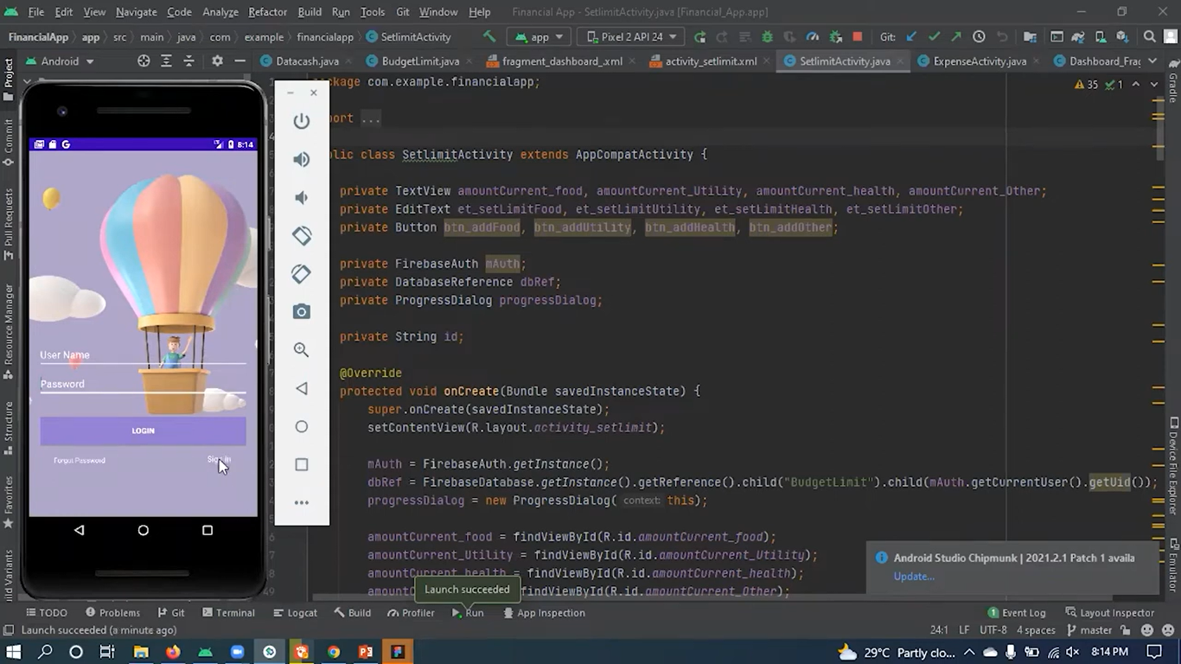

**Step2: Login in With Username and Password**

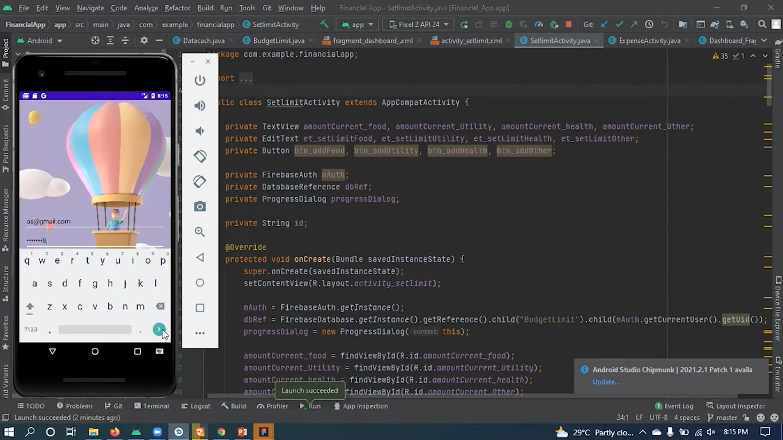

**Step3:After filled the details click the login**

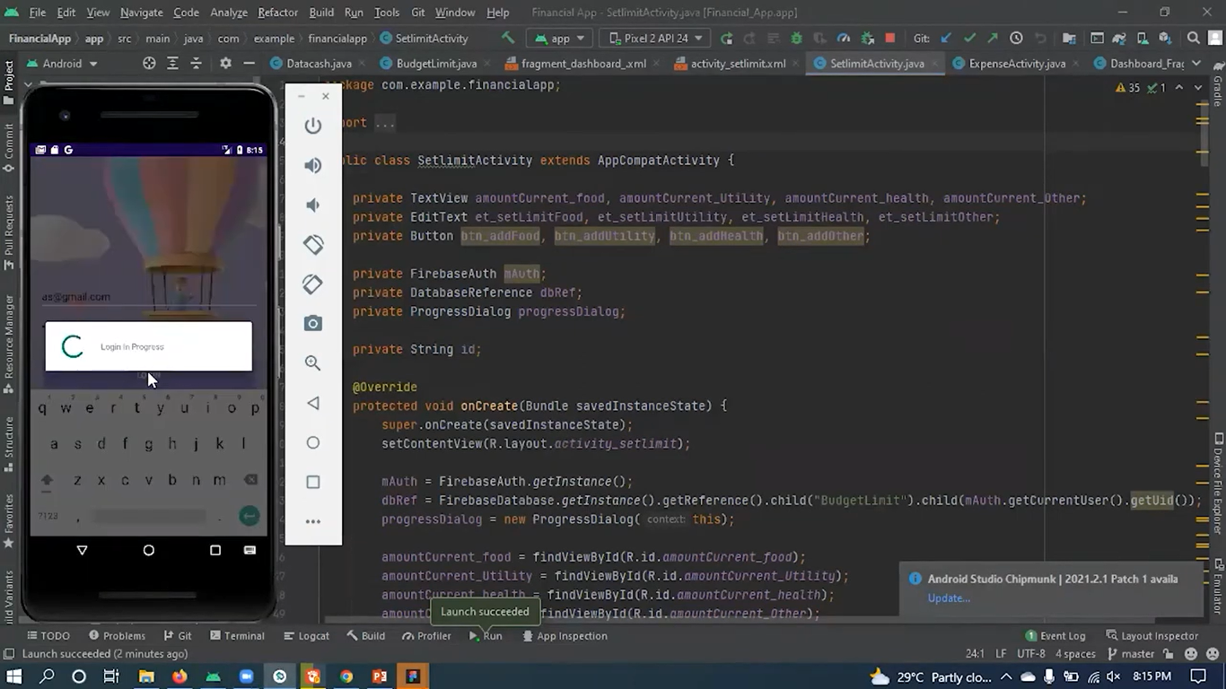

**Step4:**

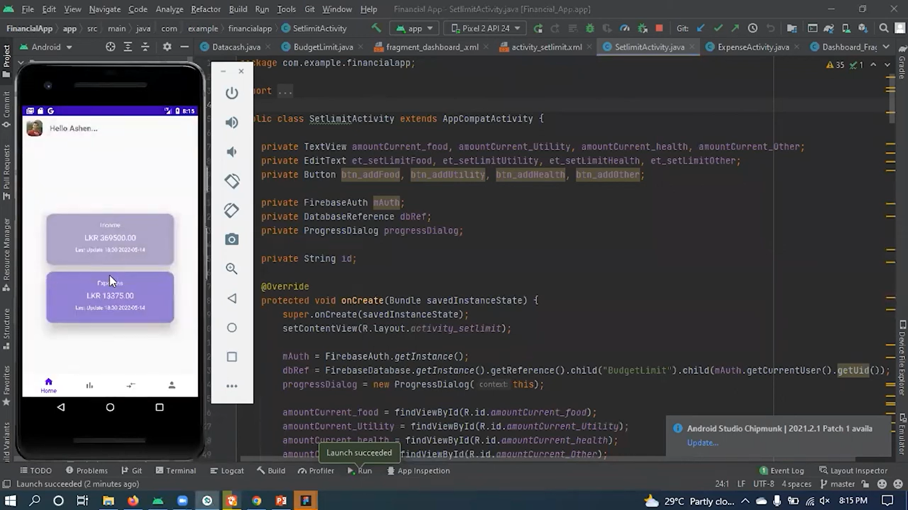

**Step5:**

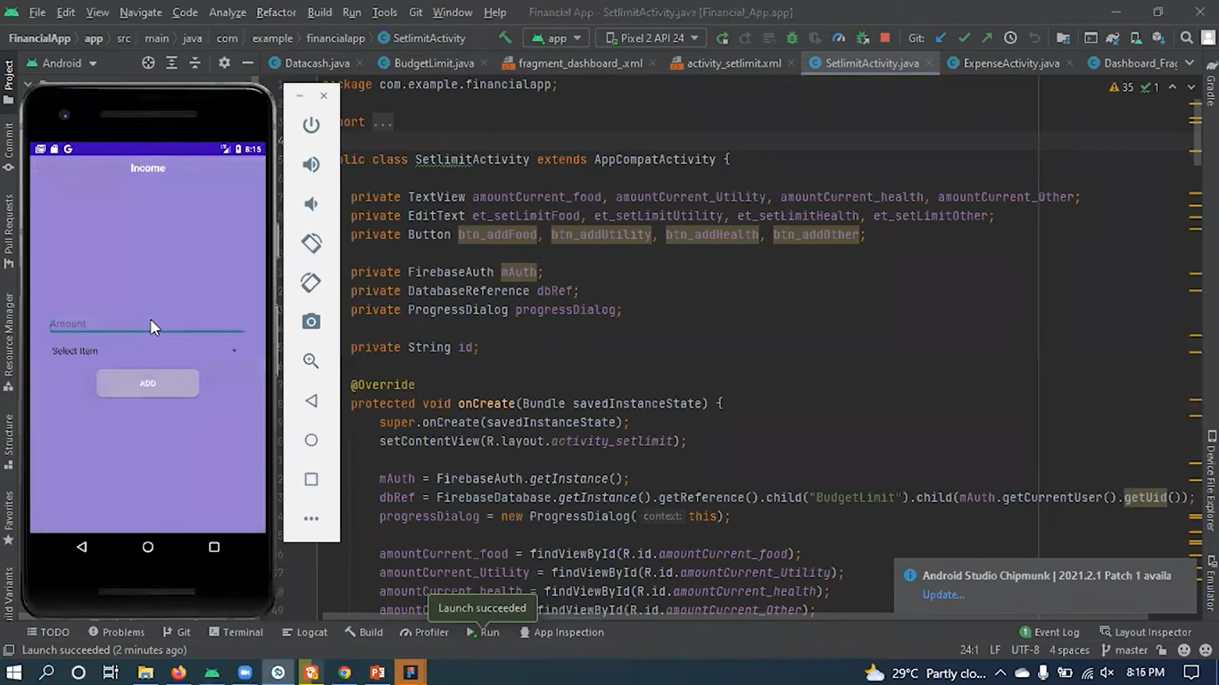

**Step6:**

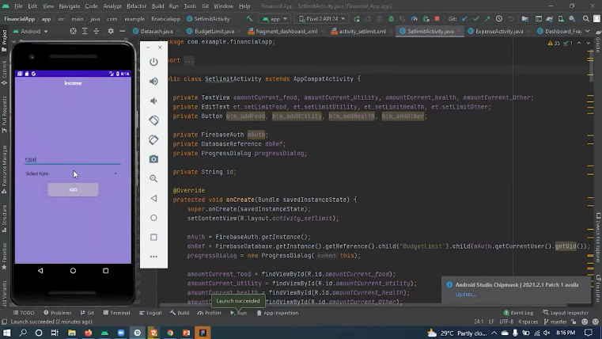 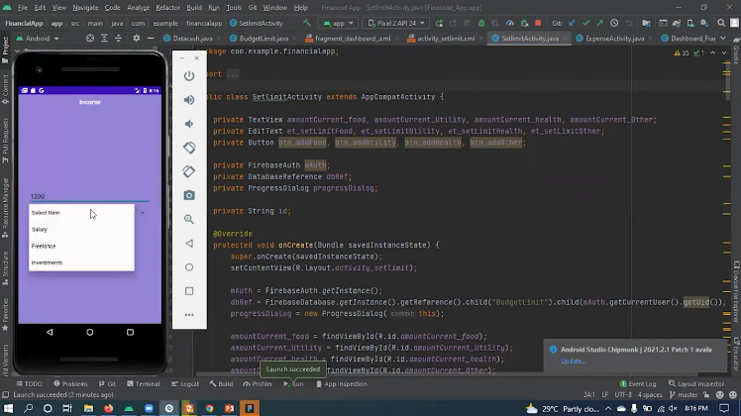

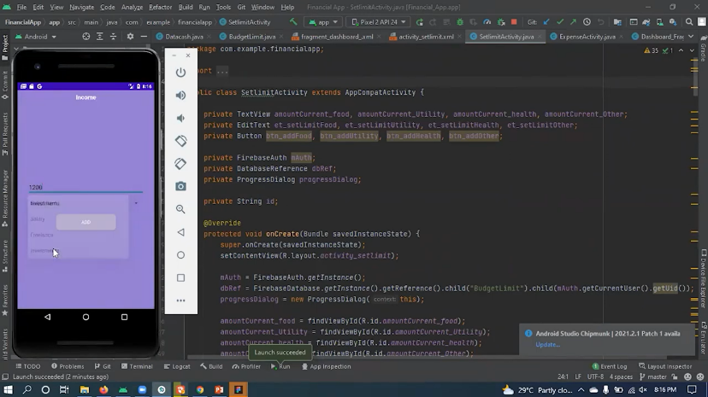

**Step7:**

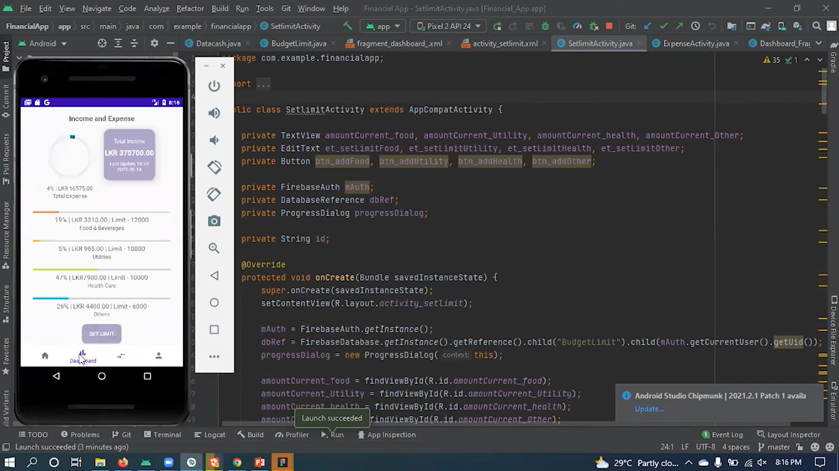

**Step8:**

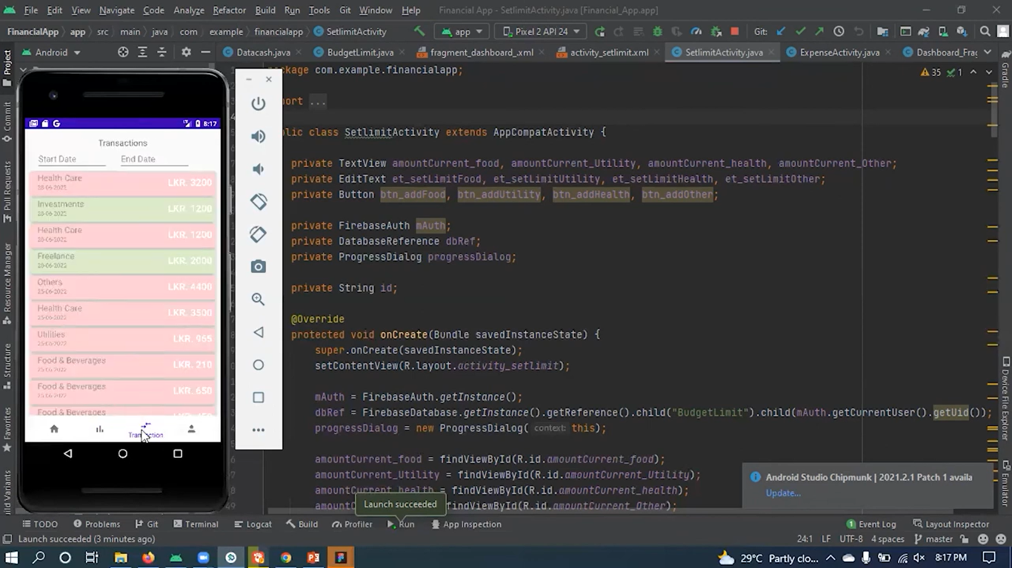

**Step9:**

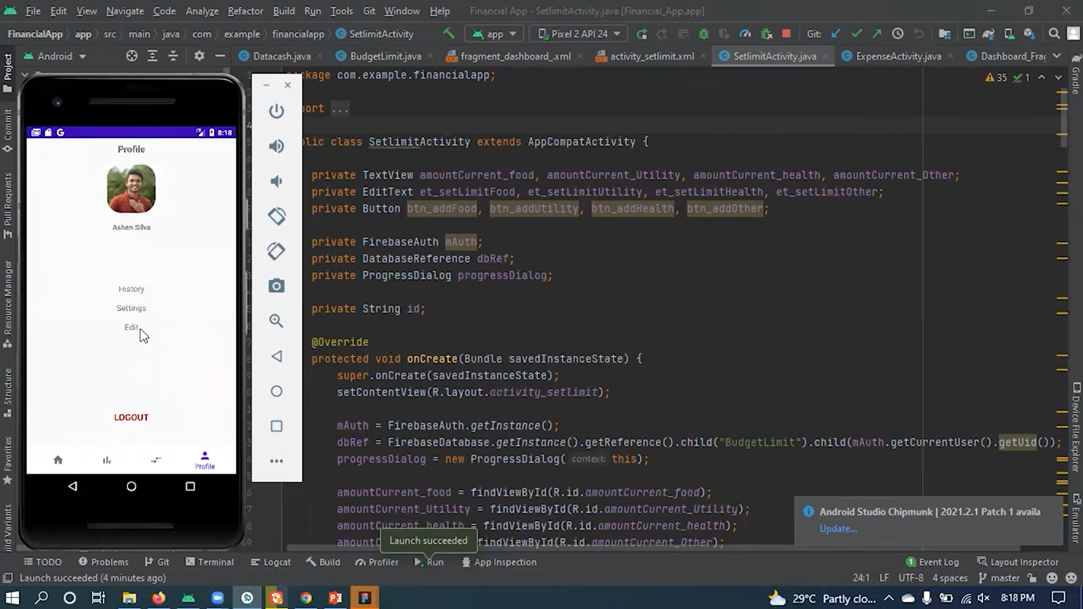

**Conclusion**

Based on this writing, it can be concluded that it is very important for every individual to plan and manage their personal finances in order to lead a happy live. It is important for every individual to have personal financial plan in order to meet their financial goals and obligation, help to retire in comfort, achieve financial freedom, make rational financial decisions and take advantage of every financial opportunity. We are all not born with these knowledge, so it should be everyone’s responsibility to learn the strategies to plan and manage our personal financial as this does not only help to lead us to a happy life but also contribute to the development of the nation in the long run.

**Reference**

Articlebase.com. (2012). The Importance of Having Personal Financial Planning. (From)

<http://www.articlebase.com/personal-finance-article/the-importance-of-having-personal-financial-planning-1712058.html>

Bimal Bhatt. (2011). Financial Management Importance. (From)

<http://www.blognbuzz.com/financial-management-importance.html>  
Career Success for Newbies. (2006). Importance of Financial Planning for Fresh Graduates Starting On Their First Jobs. (From)

http://www.career-success-for– newbies.cm/importance-of-financial-planning.html.